Making young professionals aware of higher education options with an intuitive and modern OOH campaign

Reaching an audience is half the work, if you are not on the map no one will notice your absence

Out-of-Home adverts are a key vertical for product placements and launching movies and brands. But for universities to improve enrollment they are unheard of and even unique. Nevertheless, a campaign is based on impact and effectiveness that it builds not by normalcy.

### The Client: Georgetown University School of Continuing Studies

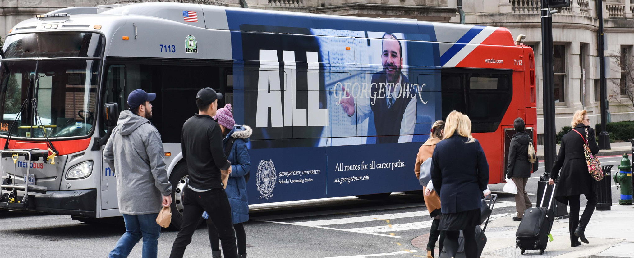

Georgetown University OOH advert on a bus

The client was a private research university who wanted to improve their enrollment metrics with young professionals. Their main aim was to be kept in the running when an applicant was considering applying for higher studies and thereby improving enrollment. To improve their reach they chose an Out-of-Home campaign with bulletin boards, digital adverts and placements at multiple corners of the city.

### Tactical approach and strategy to make positive awareness

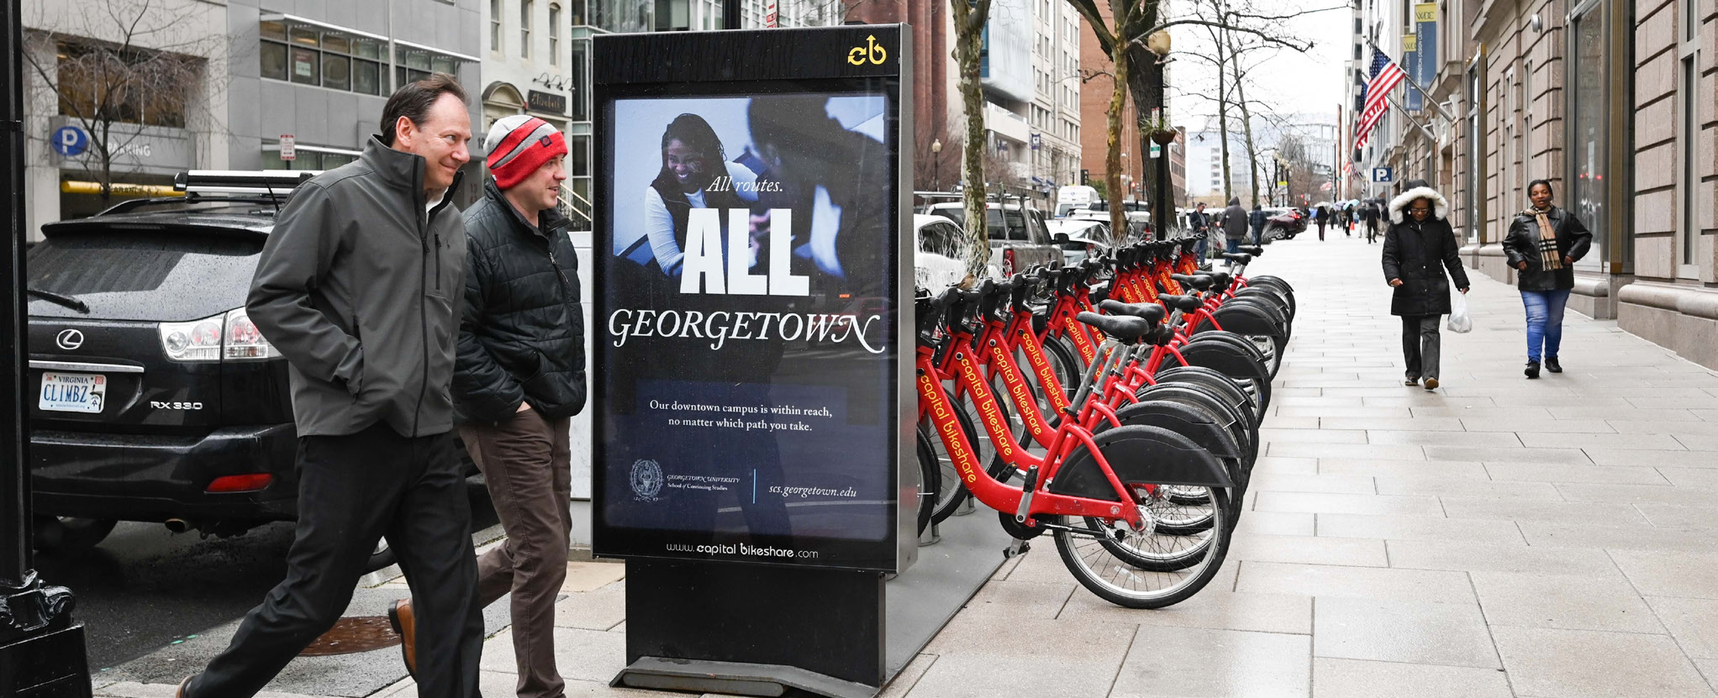

A stand alone bulletin from a Bike Share in Washington DC

In order to gain maximum potency, the campaign chose to involve multiple touchpoints throughout the Washington DC area where the university is situated. Key places were identified for placement they were -Bike Share bulletin boards, Ultra Super Kings billboards and Digital Liveaboards in the Metrorail with video trails.

All the touchpoints with the outdoor advertisements were ensured to specifically target places where young professionals lived or worked. These made sure that word of mouth also came into play.

### Creative brilliance made all adverts to have the university tagline everywhere

In every single advert digital or still it was consciously made to feature the Georgetown university tagline of ‘All Georgetown’. It made it possible to showcase accessibility in education to applicants from all walks of life and different backgrounds. The OOH campaign also made sure to include details about the flexibility of its programs, the different formats in its repertoire and highlighted the geographical position near the downtown area for students that would have preferred to have an in-class experience rather than an online one.



The tagline from an OOH bulletin placed on a Digital Liveaboard in the Metrorail

The tone of the different outdoor advertisements was tailored to be modern to capture young audiences, casual to make it less serious and approachable to make potential applicants feel at ease.

### Evaluating the measurable increase in organic searches and impressions from the Out-of-Home campaign

Since this was not a conventional OOH campaign the success of the venture was based on the organic increase in audience traffic of their website, enrollment of applicants, increase in accepted students and an increase in student acceptance in yearly measures.

The first measure is the improvement over their current website which showed significant lift in visitors from last year at 36%. Georgetown university had a low admittance rate according to their last year results but after the OOH campaign they recorded a much higher uptick in admittance rates by about 27%.

In a yearly comparison we estimated that students accepted were significantly up. The increase was rounded up to be at about 11% year over year.

### Success of the OOH campaign for Georgetown University

American Marketing Association reports that there is a positive correlation between positive brand awareness and organic search rankings and this is reflected in the unaided returns for the university and improvement in positive perception that led to more enrollment and admittance rates. It also shows that the OOH campaign does not need to be used as conventional marketing and advertising and be boxed as a tool just for product roll out or high profile launches.

All data analysed and used in this case study is credited to Georgetown University and Outfront Media.

**Bibliography**

Outfront Media. (2020). *GEORGETOWN UNIVERSITY*. GEORGETOWN UNIVERSITY. https://www.outfrontmedia.com/-/media/files/case-studies/georgetown-university-case-study.pdf